5 Web Design Patterns Used

During process of creating the website the good practices were used. Authors would like to avoid every bad practices which can exist on this type of website. First of all the authors check other, similar site and found there good and bad practices. The next step was to use patterns and heuristics method to make the website better.

The most important rule, which was adapted to website was to keep everything as easy to use as it is possible. To obtain this goal the heuristic was used.

Authors of this document decided to use Nielsen’s heuristics to check if the website is as easy to understand as possible. Some of points of the heuristic were chosen: “match between system and the real world”, “user control and freedom” and “aesthetic and minimalist design”, as the most important points in case of this type of website.

At the end of the design process the inspection method according Nielsen’s heuristic method was used again to check if website is designed in proper way. During inspection some elements of the website were improved, e.g.: the colors of the text was changed and the order of the menu was fixed to make it easier to understand.

During creating the website the language of web patterns was used. First of all the point B of pattern was considered: “creating a navigation framework”. The first thing which was made is create multiple way to navigate (B1). User can choose the movie from many ways on the website (e.g. from homepage or from menu – figure 10). The user can start a process of buying the tickets in more than one way, what is another example of multiple ways to navigate. Also, authors of this project designed good organization of content. It is connected with point B2 – browsable content. Whole site is organized in categories, what make the navigation easier. The website is created on way to allow user moves intuitive.

The website has the strict hierarchy – B3, hierarchical organization. This way of design the website allows users to feel comfortable and the possibility of getting lost is less. The website is easy to navigate. Also, authors remember that the structure of hierarchy shouldn’t be too big. It should be say that the task-based organization on this website was used (B4). The process of the buying the tickets is very linear (but as it was said before – it can start in other ways), and every next step (task) of buying is connected with previous one. This organization makes user sure that he completed all tasks in proper order.

Inside the website the D7 web pattern was used. The inverted-pyramid writing style is used to show the user the most important information and allow to him find the rest part of information. In this way user isn’t lost with too many information in the same time.

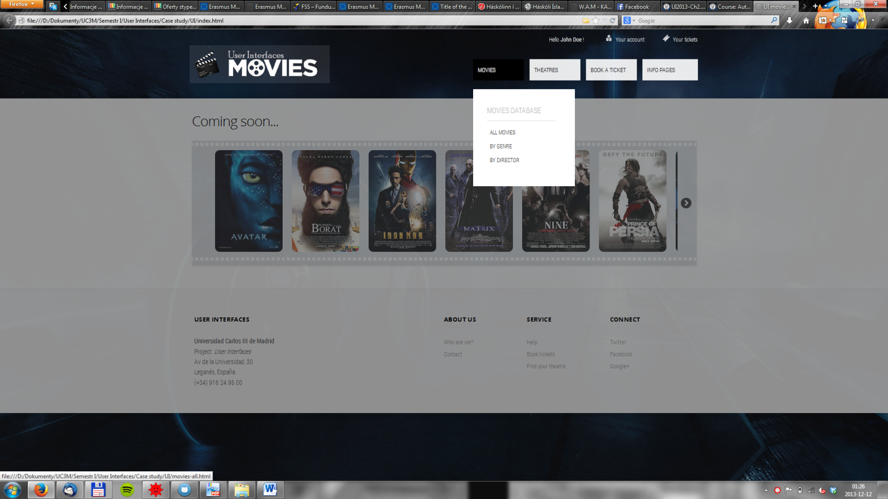

Figure 10. Possibility to choose the movie in many ways.